Blockchain Visualisation Web App

FYP Proposal 2017

# Abstract

A web app which imitates a working block chain network for visualisation and learning. A block chain is essentially a shared database which exists across a network of cooperating computers. Data can be added but never removed. The proposed web app will create a dynamic visual experience which will be used to understand how the network is initialised, how it expands and how it is maintained without a central authority.

# Software

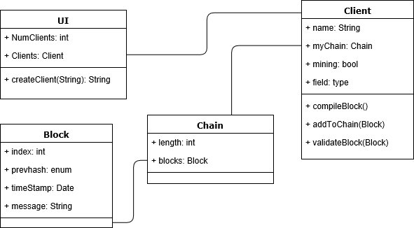

The app will be developed with the **JavaScript** language using Object Orientated Programming (OOP). The language is chosen for its compatibility with most browsers and its visual creative abilities. Time and experience permitting, the project can be reconfigured into a **Node.js** application allowing for user interaction across a shared Blockchain network.

The blockchain visualisation app will be hosted on **Heroku**, a Platform as a Service (PaaS) with Git integration and a range of innovative features. The web app’s data will be stored using **MongoDB**, a database program using a JSON like format for data storage.

The development process will use **Git** for version control.

# Discussion

The Blockchain being demonstrated will not intentionally imitate any existing Blockchain system. It will resemble Bitcoin’s block layout and hashing technique but without any of the currency and wallet software in place. Instead of transaction data, the blockchain will be used to store messages added by the users. The project will be visual-orientated. The technical complexity of the system will be used solely as a resource for the design process. If time and complexity become restrictive, focus of the work will be placed on the completion of a user friendly experience over a complex, practical application.